Q1. (a) Fill in the blanks. (7 marks)

|  |  |  |  |  |  |  |
| --- | --- | --- | --- | --- | --- | --- |
| **IEEE 802.3 Ethernet Frame Fields** | | | | | | |
| **7 bytes** | **1 byte** | **6 bytes** | **6 bytes** | **2 bytes** | **46-1500**  **bytes** | **4 bytes** |
| Preamble | Start of Frame Delimiter | Destination Address | Source Addresss | Length | 802.2 Header and Data | Frame Check Sequence |

1. The Ethernet MAC sublayer has 2 primary responsibilities which are data encapsulation and Media Access Control (MAC).
   1. Describe the **THREE (3)** primary functions of data encapsulation. (6 marks)
2. **Frame delimiting.** Identifies the bounds of a frame, synchronization between sender & receiver hosts
3. **Addressing**. Bundles the MAC address together for delivery to destination node.
4. **Error detection.** To include a trailer to detect errors in transmission.

**Discussed Answer:**

* 1. Discuss **TWO (2)** primary functions of Media Access Control. (4 marks)
* Controls the placement of frames on the media and the removal of frames from the media.
* Initiaition of frame transmission and recovery from transmission failure

1. Describe **TWO (2)** frame forwarding methods available on Cisco switches. (6 marks)

* **Store-and-forward switching.** Receives the entire frame and compute the CRC. If the CRC is valid, the frame is forwarded.
* **Cut-through switching**. Forwards the frame before it is entirely received. At minimum, the destination address must be read.

Q2. (a) In a Local Area Network, ARP request is a layer 2 broadcast messages. All the devices in the LAN received the Address Resolution Protocol (ARP) request except the sending device.

* 1. What is the purpose of the ARP? (2 marks)
* Translate IPv4 addresses to MAC addresses
* Maintains a dictionary of mappings
  1. What is the action taken by a node if the node’s IP address matched the IP address in the ARP request? (2 marks)
* The device will respond to the ARP request and reply with it’s MAC address.
  1. What happens if no device on the LAN responds to the ARP request? (2 marks)
* The packet is dropped because a frame cannot be created.
  1. Name and explain **ONE (1)** reason ARP can cause a problem in a network. (3 marks)

**ARP Spoofing.** An attacker can inject wrong MAC address into the network by faking its

MAC address and replying. Frames can be sent to the wrong destination.

OR

* **Overhead on the media.** As a broadcast frame, an ARP request is received and processed by every device on the local network.
  1. What is ARP table used for? (4 marks)
* Used to find Data Link Layer address corresponding to the IP address
* As a central node to receive frames from media, and provides routing to frames

1. Determine the correct sublayer for the following descriptions. (6 marks)

|  |  |
| --- | --- |
| **Descriptions** | **MAC or LLC?** |
| 1. Controls the network interface card through software drivers | LLC |
| 2. Works with the upper layers to add application information for delivery of data to higher level protocols | LLC |
| 3. Works with hardware to support bandwidth requirements and checks errors in the bits sent and received | MAC |
| 4. Controls access to the media through signaling and physical media standards requirements | MAC |
| 5. Supports Ethernet technology by using CSMA/CD or CSMA/CA | MAC |
| 6. Remain relatively independent of physical equipment | LLC |

1. Ethernet separates the functions of the Data Link layer into 2 distinct sublayers. List and briefly explain the relationship between the sublayers. (6 marks)

* Logical Link Control (LLC) sublayer and Media Access Control (MAC) sublayer.
* LLC is implemented in software and enables the data link layer to communicate with the upper layers of the protocol suite.
* The NIC driver software interacts with the hardware on the NIC to pass the data between the mAC sublayer and the physical media.

Q3. (a) Inspect the following MAC addresses; is this a proper MAC address? If no, why?

* 1. 77:EE:33:AA:DD (2 marks)

No. MAC address has 12 hexadeecimal characters. The given example is not a valid MAC address which only contains 10 hex characters.

(ii) 01-34-45-7U-8B-P9 (2 marks)

Invalid. 7U and P9 are not a valid value for hexadecimal representation

(iii) FI00:5678.910C (2 marks)

Invalid. MAC address consists only of six groups of two hex digits, not 3 groups of 4 hex digits.

1. In Ethernet, different MAC addresses are used for unicast, multicast, and broadcast communications. Give relevant example of MAC used in unicast, multicast, and broadcast delivery. (6 marks)

Unicast, broadcast, and multicast are all 48-bit MAC address types. All of them can be destination MAC addresses.

Unicast: Only unicast can be a source address. A unicast address is a unique address used when a frame is sent from a single transmitting device to a single destination device. Example: A0-C9-B3-23-56-89

Broadcast: In the case of a broadcast, the frame is destined for all devices in the broadcast domain and is addressed to a MAC broadcast address. Example: FF-FF-FF-FF-FF-FF

Multicast: With multicast, a source can send to a group of devices. The low-order bit of the first byte must be a 1 for the address to be a multicast. If the multicast is also an IP multicast, the first 24 bits of the MAC address are 01-00-5E in hexadecimal. Example: 01-00-5E-F4-50-7A

1. Refer to the exhibit. The exhibit shows a small switched network and the contents of the MAC address table of the switch. PC1 has sent a frame addressed to PC3. What will the switch do with the frame? (6 marks)

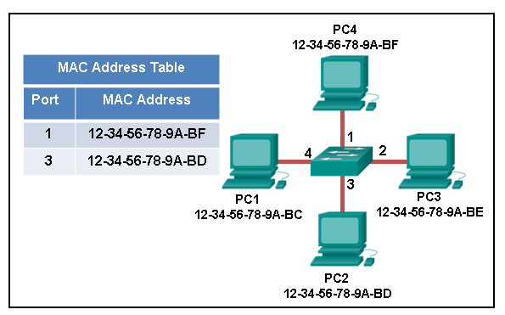

1. The MAC address is not present in the MAC table of the switch. Because the switch does not know where to send the frame that is addressed to PC4, it will forward the frame to all the switch ports, except for port 4, which is the incoming port.